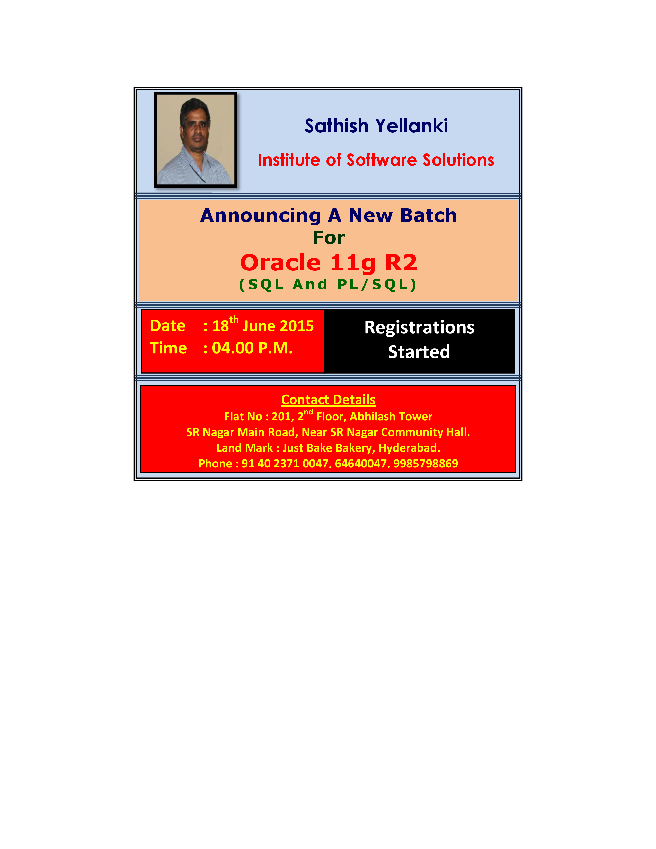SQL> cl scr

SQL> SELECT Deptno, Job, SUM(Sal) SalSum
2 FROM Emp
3 GROUP BY ROLLUP(Deptno, Job);

DEPTNO JOB SALSUM
---------- --------- ----------
10 CLERK 1300
10 MANAGER 2450
10 PRESIDENT 5000
10 8750
20 CLERK 1900
20 ANALYST 6000
20 MANAGER 2975
20 10875
30 CLERK 950
30 MANAGER 2850
30 SALESMAN 5600
30 9400
29025

13 rows selected.

SQL> ED
Wrote file afiedt.buf

1 SELECT GROUP_ID() GrpID, Deptno, Job, SUM(Sal) SalSum
2 FROM Emp
3* GROUP BY ROLLUP(Deptno, Job)
SQL> /

GRPID DEPTNO JOB SALSUM
---------- ---------- --------- ----------
0 10 CLERK 1300
0 10 MANAGER 2450
0 10 PRESIDENT 5000
0 10 8750
0 20 CLERK 1900
0 20 ANALYST 6000
0 20 MANAGER 2975
0 20 10875
0 30 CLERK 950
0 30 MANAGER 2850
0 30 SALESMAN 5600
0 30 9400
0 29025

13 rows selected.

SQL> ED
Wrote file afiedt.buf

1 SELECT
2 GROUPING_ID(Deptno, Job) GrpIDX,
3 GROUP_ID() GrpID,
4 Deptno,
5 Job,
6 SUM(Sal) SalSum
7 FROM Emp
8 GROUP BY ROLLUP(Deptno, Job)
9* ORDER BY GrpIDX
SQL> /

GRPIDX GRPID DEPTNO JOB SALSUM
---------- ---------- ---------- --------- ----------
0 0 10 CLERK 1300
0 0 10 MANAGER 2450
0 0 10 PRESIDENT 5000
0 0 20 MANAGER 2975
0 0 30 SALESMAN 5600
0 0 30 MANAGER 2850
0 0 30 CLERK 950
0 0 20 CLERK 1900
0 0 20 ANALYST 6000
1 0 30 9400
1 0 20 10875
1 0 10 8750
3 0 29025

13 rows selected.

SQL> ED
Wrote file afiedt.buf

1 SELECT
2 GROUP_ID() GrpID,
3 Deptno,
4 Job,
5 SUM(Sal) SalSum
6 FROM Emp
7* GROUP BY Deptno, ROLLUP(Deptno, Job)
SQL> /

GRPID DEPTNO JOB SALSUM
---------- ---------- --------- ----------
0 10 CLERK 1300
0 10 MANAGER 2450
0 10 PRESIDENT 5000
0 20 CLERK 1900
0 20 ANALYST 6000
0 20 MANAGER 2975
0 30 CLERK 950
0 30 MANAGER 2850
0 30 SALESMAN 5600
0 10 8750
0 20 10875
0 30 9400
1 10 8750
1 20 10875
1 30 9400

15 rows selected.

SQL> ED
Wrote file afiedt.buf

1 SELECT
2 GROUP_ID() GrpID,
3 Deptno,
4 Job,
5 SUM(Sal) SalSum
6 FROM Emp
7* GROUP BY Deptno, CUBE(Deptno, Job)
SQL> /

GRPID DEPTNO JOB SALSUM
---------- ---------- --------- ----------
0 10 CLERK 1300
0 10 MANAGER 2450
0 10 PRESIDENT 5000
0 20 CLERK 1900
0 20 ANALYST 6000
0 20 MANAGER 2975
0 30 CLERK 950
0 30 MANAGER 2850
0 30 SALESMAN 5600
1 10 CLERK 1300
1 10 MANAGER 2450
1 10 PRESIDENT 5000
1 20 CLERK 1900
1 20 ANALYST 6000
1 20 MANAGER 2975
1 30 CLERK 950
1 30 MANAGER 2850

GRPID DEPTNO JOB SALSUM
---------- ---------- --------- ----------
1 30 SALESMAN 5600
0 10 8750
0 20 10875
0 30 9400
1 10 8750
1 20 10875
1 30 9400

24 rows selected.

SQL> ED
Wrote file afiedt.buf

1 SELECT
2 Deptno,
3 Job,
4 SUM(Sal) SalSum
5 FROM Emp
6 GROUP BY Deptno, ROLLUP(Deptno, Job)
7* HAVING GROUP_ID() = 0
SQL> /

DEPTNO JOB SALSUM
---------- --------- ----------
10 CLERK 1300
10 MANAGER 2450
10 PRESIDENT 5000
20 CLERK 1900
20 ANALYST 6000
20 MANAGER 2975
30 CLERK 950
30 MANAGER 2850
30 SALESMAN 5600
10 8750
20 10875
30 9400

12 rows selected.

SQL> cl scr

SQL> SELECT * FROM Emp;

EMPNO ENAME JOB MGR HIREDATE SAL COMM DEPTNO
---------- ---------- --------- ---------- --------- ---------- ---------- ----------
7839 KING PRESIDENT 17-NOV-81 5000 10
7698 BLAKE MANAGER 7839 01-MAY-81 2850 30
7782 CLARK MANAGER 7839 09-JUN-81 2450 10
7566 JONES MANAGER 7839 02-APR-81 2975 20
7654 MARTIN SALESMAN 7698 28-SEP-81 1250 1400 30
7499 ALLEN SALESMAN 7698 20-FEB-81 1600 300 30
7844 TURNER SALESMAN 7698 08-SEP-81 1500 0 30
7900 JAMES CLERK 7698 03-DEC-81 950 30
7521 WARD SALESMAN 7698 22-FEB-81 1250 500 30
7902 FORD ANALYST 7566 03-DEC-81 3000 20
7369 SMITH CLERK 7902 17-DEC-80 800 20
7788 SCOTT ANALYST 7566 09-DEC-82 3000 20
7876 ADAMS CLERK 7788 12-JAN-83 1100 20
7934 MILLER CLERK 7782 23-JAN-82 1300 10

14 rows selected.

SQL> SELECT Deptno, SUM(Sal) SalSum
2 FROM Emp
3 GROUP BY Deptno;

DEPTNO SALSUM
---------- ----------
30 9400
20 10875
10 8750

SQL> SPOOL OFF

